Fashion MNIST Dataset

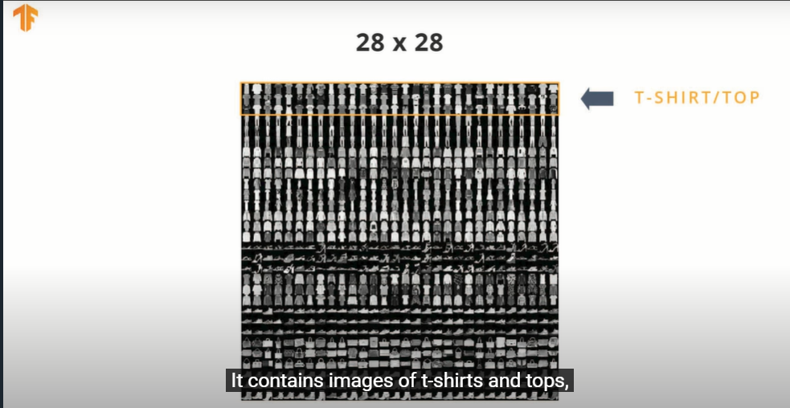

# The Rectified Linear Unit (ReLU)

In this lesson we talked about ReLU and how it gives our Dense layer more power. ReLU stands for Rectified Linear Unit and it is a mathematical function that looks like this:

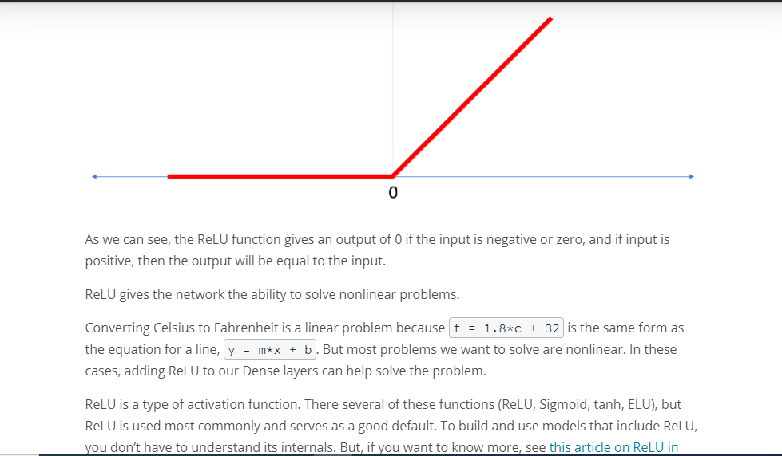

Let’s review some of the new terms that were introduced in this lesson:

* **Flattening:** The process of converting a 2d image into 1d vector
* **ReLU:** An activation function that allows a model to solve nonlinear problems
* **Softmax:** A function that provides probabilities for each possible output class
* **Classification:** A machine learning model used for distinguishing among two or more output categories

NEXT